Nisrina Salsabila H

20230140054

Praktikum 1 Pengembangan Desain Web

Code:

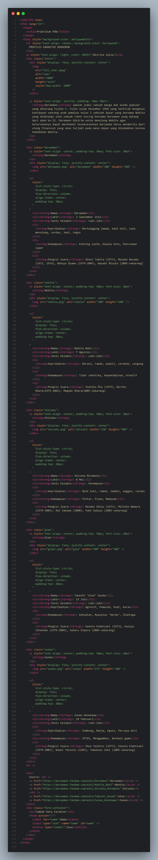

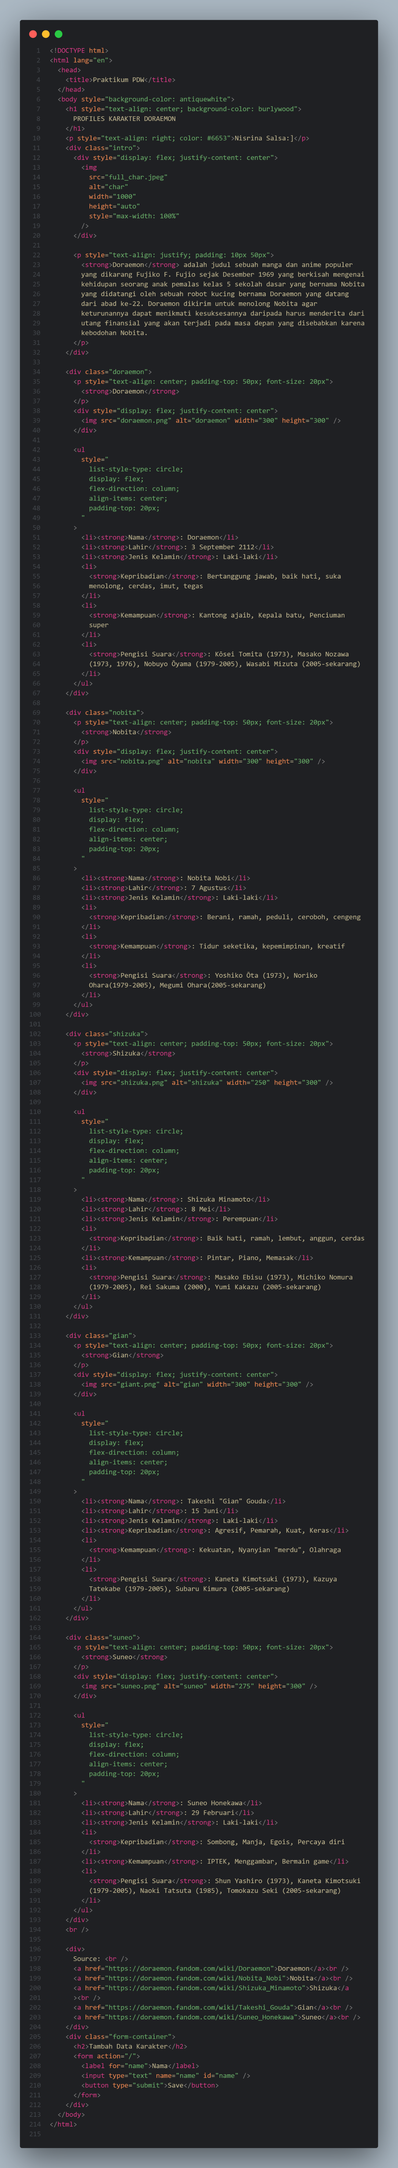





Hasil Web:

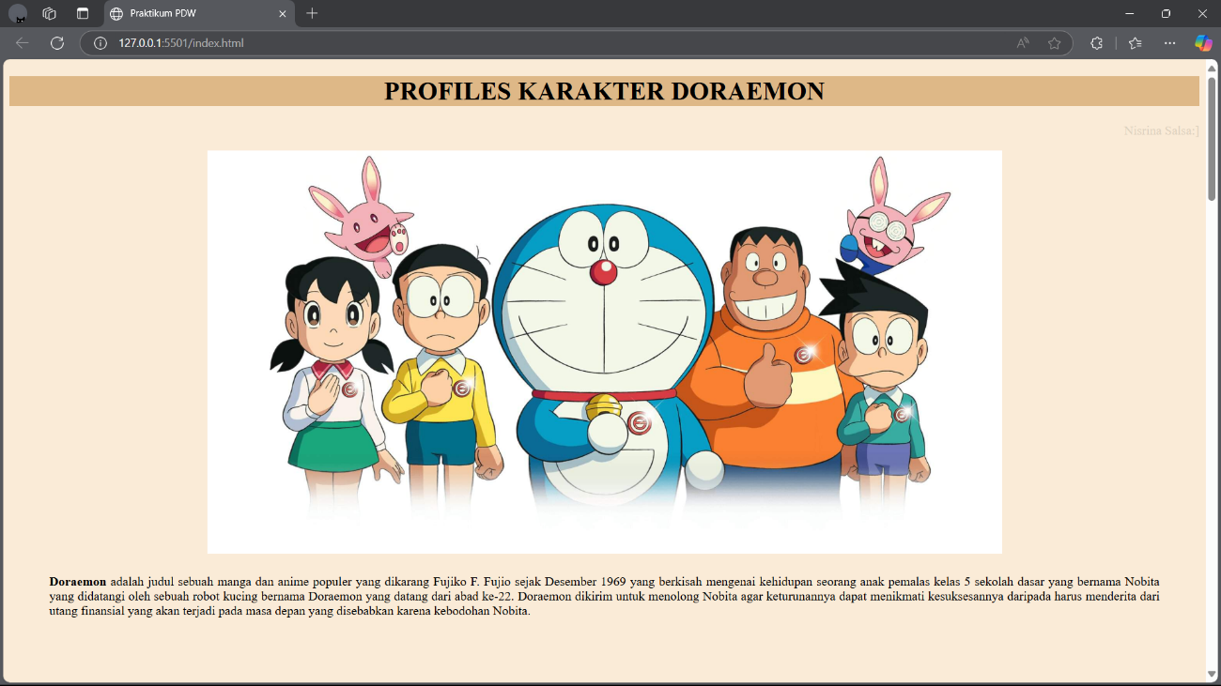

Full screenshot web:

